VENUE
Foundation for Research and Technology-Hellas
N. Plastira 100
70013 Voutes Heraklion
www.ics.forth.gr


FORTH FACILITIES
The facilities of FORTH (www.ics.forth.gr) are located just outside the city of Heraklion (N.Plastira 100, Vassilika Vouton). Here is a map of the itinerary from the city center:
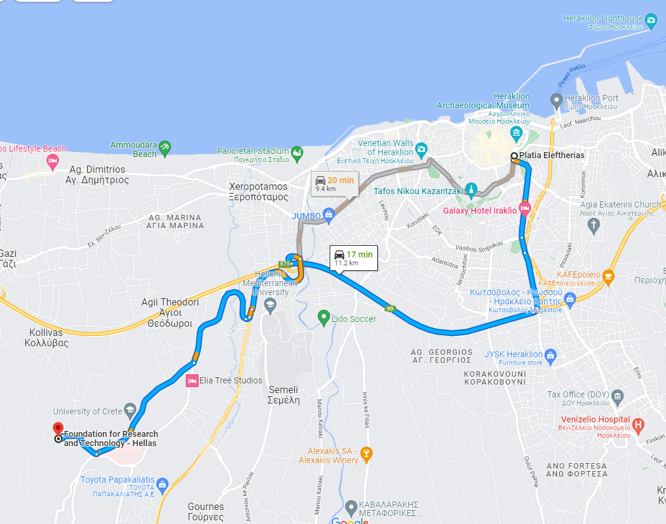
Transportation options
There are two main bus stops in the center. The first bus stop is right next to Astoria Capsis Hotel. There are also other suggested hotels that are quite close to the bus stops. The route takes about 40 minutes by bus (heading ITE or PAGNI) and the ticket costs 1,50 € (blue ticket). Ticket vending machines are located next to most bus stations in the centre but you can also buy from most kiosks around the city. Please keep in mind that city traffic may affect departure and arrival times. For further information and timetable, you can check the following link: http://astiko-irakleiou.gr/#en or you can download the application “Iraklio City Bus” to your mobile phone.
In addition, you can get a taxi which takes no more than 20 minutes, depending on the traffic, and costs approximately 12 € from Eleftherias Square, plus €2 for call service. You can call (+30) 2810 321330 or (+30) 2810 210102 for a taxi.

All Venue Rooms are located at the Central Building, straight ahead from the entrance.
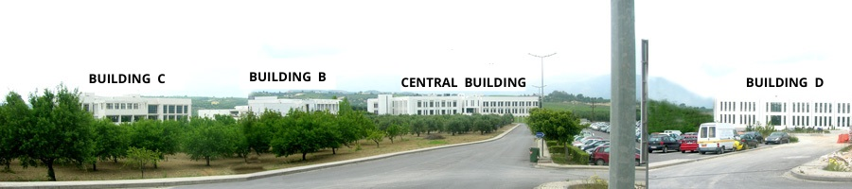
Please follow the signs in the building.

SUGGESTED RESTAURANTS
Here are some suggested restaurants (and there are many more, as usually most taverns in Heraklion and Crete are very good and traditional)

(30-50 euros per person)

- PESKESI
Kapetan Haralampi 6-8, Heraklion
Tel. +30 2810 288887
http://peskesicrete.gr/en/
Category: mostly traditional dishes

- PARASTIES
Chandakos 81, Heraklion 712 02
Tel. +30 2810 225009
http://www.parasties.gr/en
Category: all kind of dishes

- APIRI
Agion Deka 5, Heraklion 712 02
Tel. +30 281 034 2228
https://apiri-greek-eatery.business.site/
Category: all kind of dishes
(15-25 euros per person)

- PARALIA SEASIDE RESTAURANT
S. Venizelou 5, Heraklion
Tel. +30 2810282475
http://www.paraliacrete.gr/index.html
Category: seafood

- IPPOKAMPOS
S. Venizelou 3, Heraklion
Tel. +30 2810280240
http://www.ippokamposirakleio.com/
Category: seafood
- ERGANOS
G. Georgiadi 5, Heraklion
Tel 2810-285629
http://www.erganos.gr/index.php?pageid=home
Category: Cretan dishes

- OUZERI TOU TERZAKI
L. Marinelli 17, St.Dimitiou’s Square, Heraklion
Tel +30 2810 221444
http://terzakhs.gr/
Category: Traditional Cretan Fish/Seafood.

- VOURVOULADIKO
M. Kardiotissis 71, Heraklion
Tel +30 281 033 5323
https://www.facebook.com/profile.php?id=100063526092254&rf=680370038714498
Category: Traditional Cretan

- MERASTRI
L. Marinelli 17, St.Dimitiou’s Square, Heraklion
Tel +30 281 022 1910
https://www.facebook.com/MERASTRI/
Category: all kind of dishes

- ARISMARI & VARSAMO
Lisimahou Kalokairinou 10, Heraklion
Tel +30 281 030 0670
https://www.arismari.gr/
Category: Traditional Cretan

WHAT TO DO IN HERAKLION
Heraklion is a city full of history and things to do. The most famous attraction is the palace of Knossos located outside of the city and the Archeological Museum in the city center, where in both places you can watch the Minoan life unravel. Another important museum is the Historical Museum, also in the city center, which is the perfect place to have a look at the more recent history of the town. Also, the Natural History Museum of Crete will give you a great taste of the local fauna and flora. By the sea you can also visit the fortress of ‘Koules”, and you can take a walk anytime on the Venetian Walls or besides and under them, visiting the bastions and the city gates. On the bastion of Martinengo you will also find the tomb of Nikos Kazantzakis
The city, being on a crossroad of the Mediterranean history for centuries, is filled with sights (archeological sites, Venetian and Turkish buildings, churches, fountains) with historical significance that are scattered throughout the city.
Here are the top attractions of Heraklion:
https://www.cretanbeaches.com/en/cities-and-towns-in-crete/heraklion-city
Take a stroll by the seaside or get lost in the old city town inside the venetian walls! The city itself is walkable and here you can find maps and suggested routes to discover it: https://www.heraklion.gr/en/visitor/walking-town
Last but not least, the closest beaches, reachable also by bus, are Ammoudara and Karteros.

